RVPlasticParts

Rudder Clevis Fairing Installation Instructions

Weight: 4 grams total for both sides

Parts supplied per set:
2 upper fairings
2 lower fairings
2 lower buttons
1 nut install tool

Step 1: Visually check existing cotter pin hole to bolt head alignment. These fairing fit the most common cotter pin hole / bolt head orientation we have found. If yours are not in this oriented in this fashion you may find another bolt that is. The cotter pin hole orientation is to align with one of the bolt head corners, or close to it.
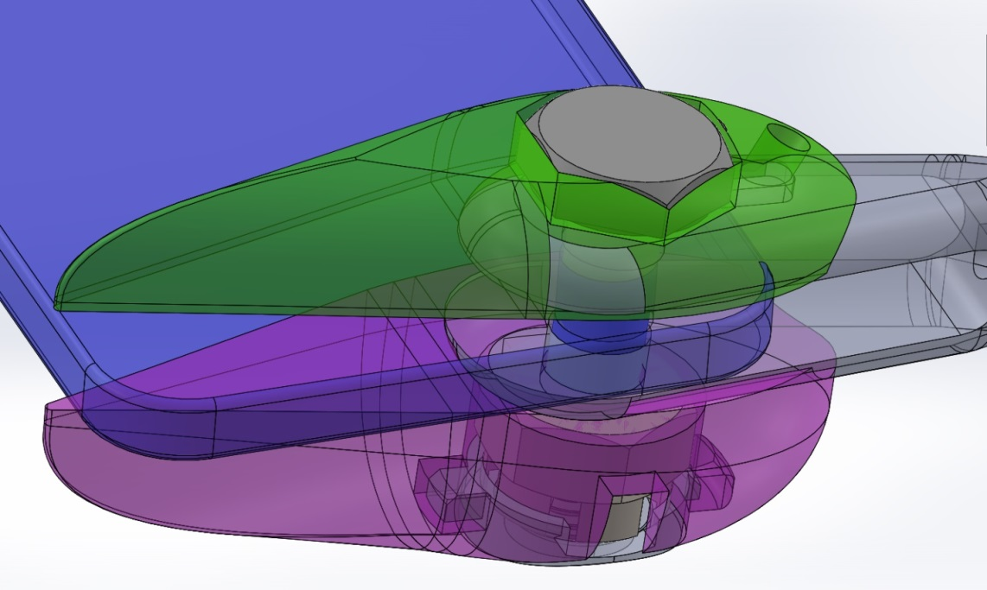

Step 2: Disassemble the installed rudder clevis bolted attachment.
Step 3: Install the original bolt size thru the top fairing and install bolt thru rudder clevis and rudder horn. No washer.
Step 4: Install bottom fairing on bolt. No washer.
Step 5: Install castle nut on bolt using the supplied nut tool. Tighten one castle nut groove after contact. They only need a light clamp force. Over tighten will cause the aft edges of the fairing to contact the rudder horn and is not desired.

(Continued next pages)
Step 6: Trim cotter pin long side approximately 0.2 inch.

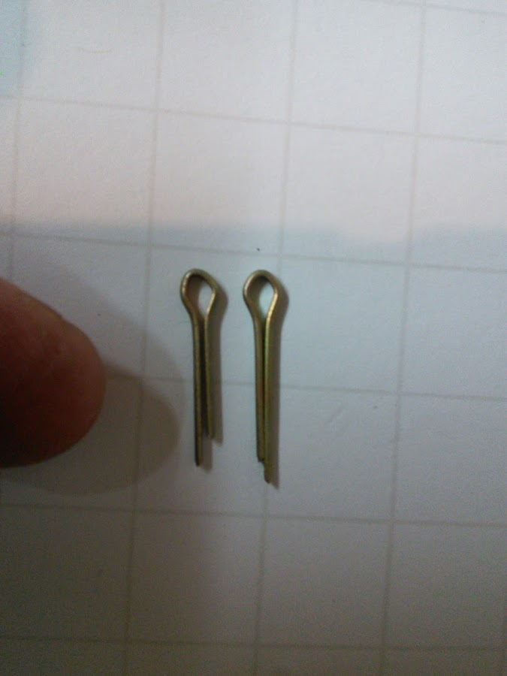

Step 7: Install cotter pin and bend to position with the short side up.
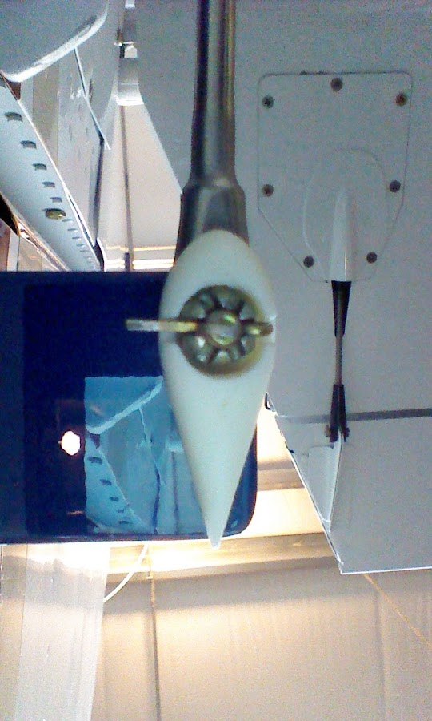

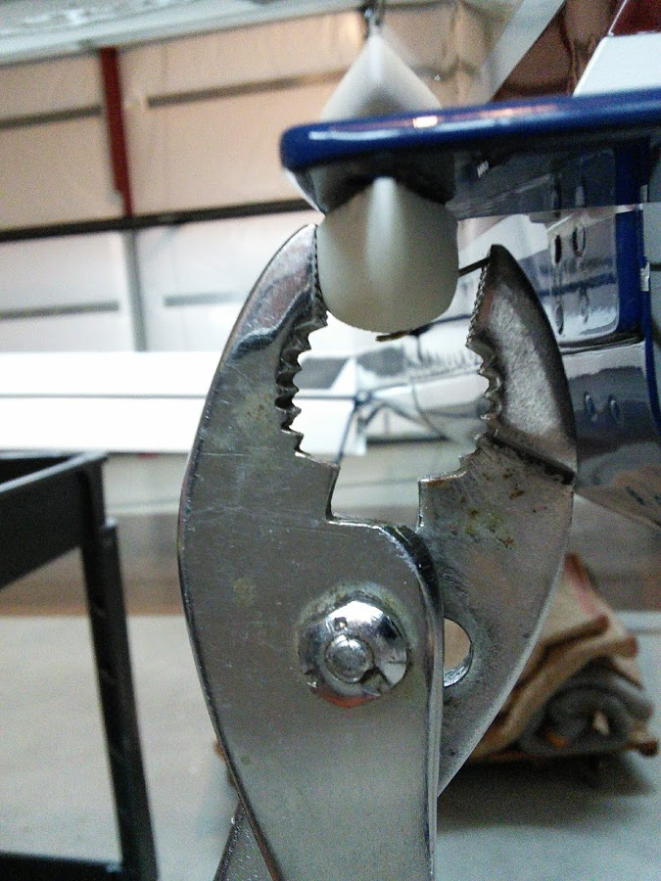

Step 8: Install small button on bottom fairing. Insert the button tang to aft side of the bottom fairing and snap into position.
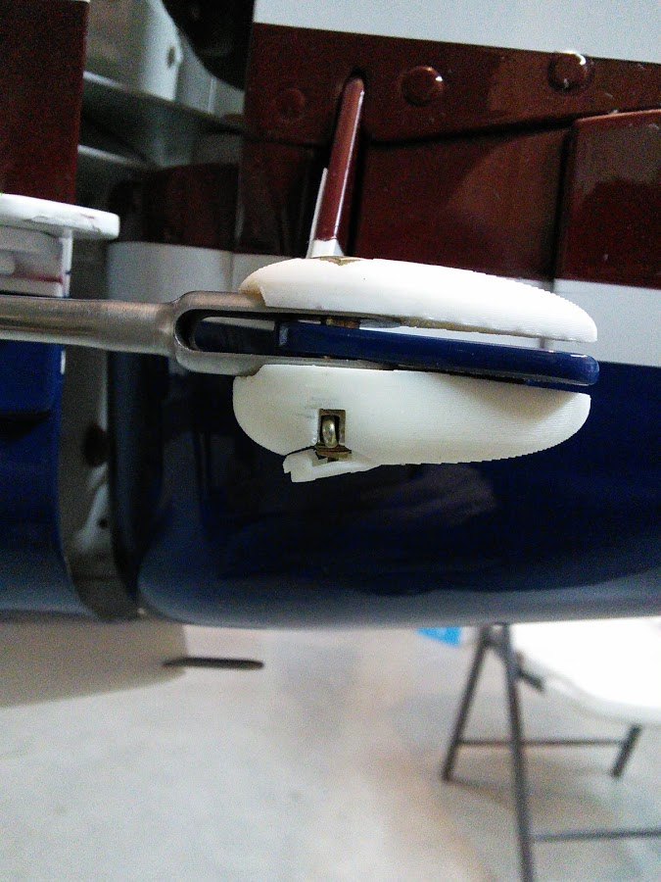
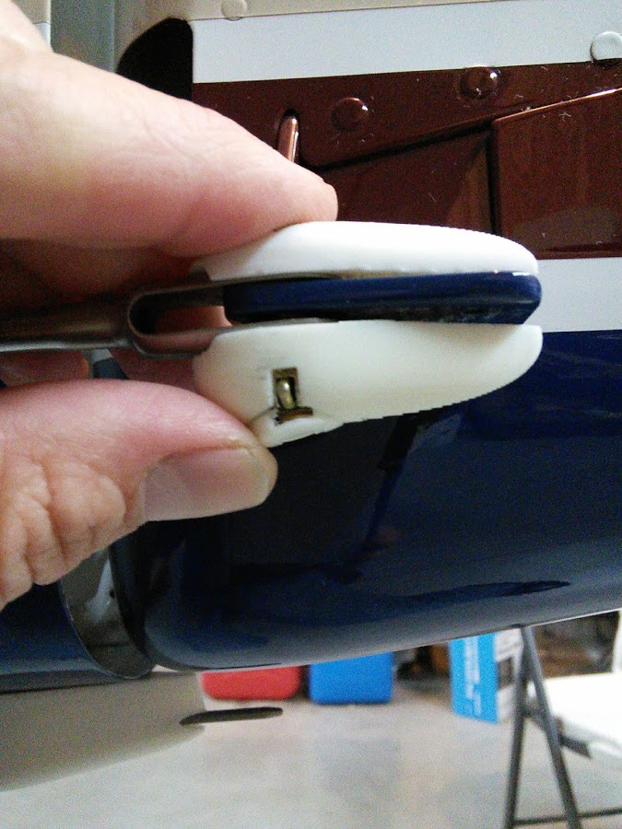
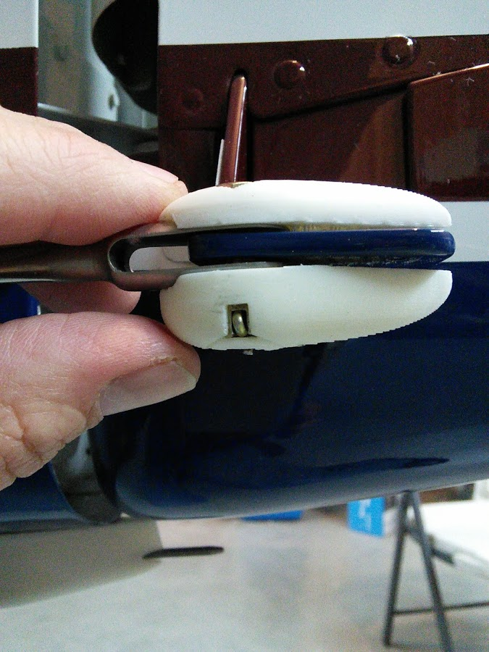
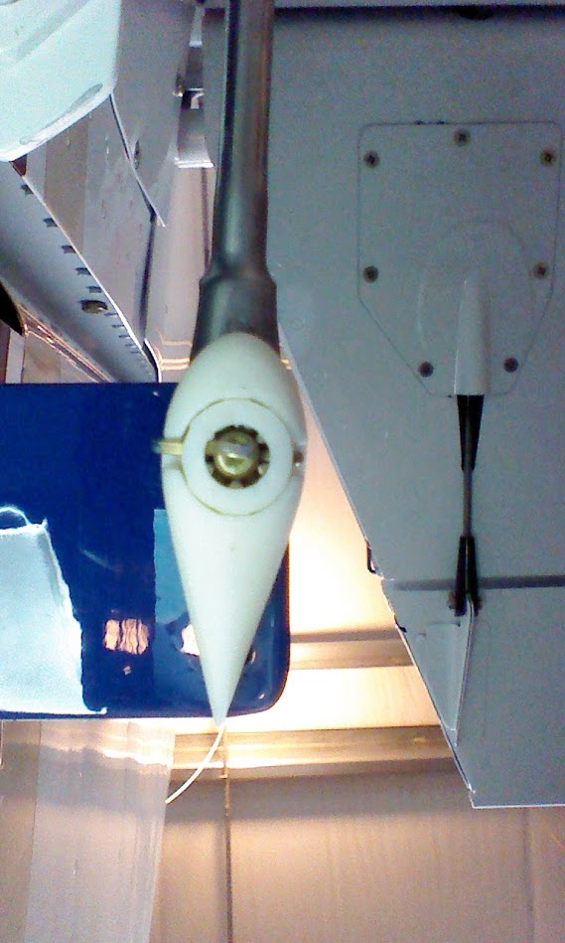
Step 9: Verify the rudder moves freely with no interference to the fairings.
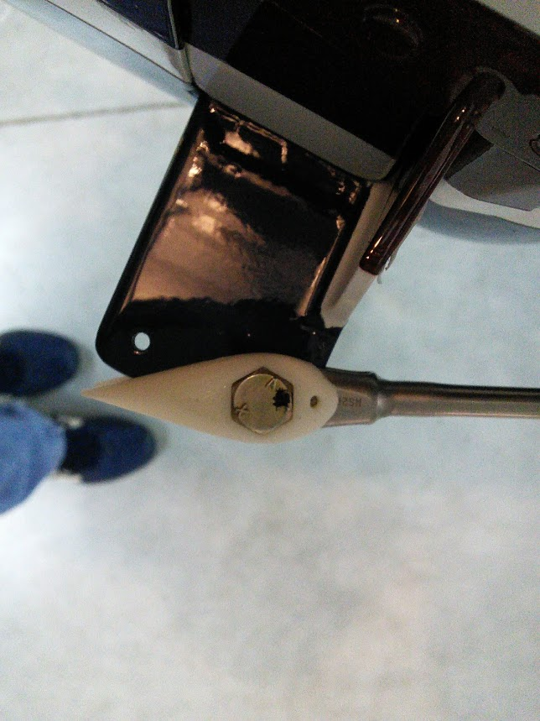

Oil lube hole provided.
