RVPlasticParts.com
Elevator Gust Lock Measurements
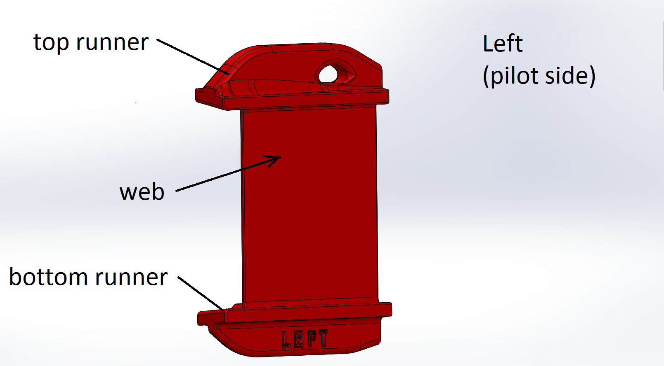

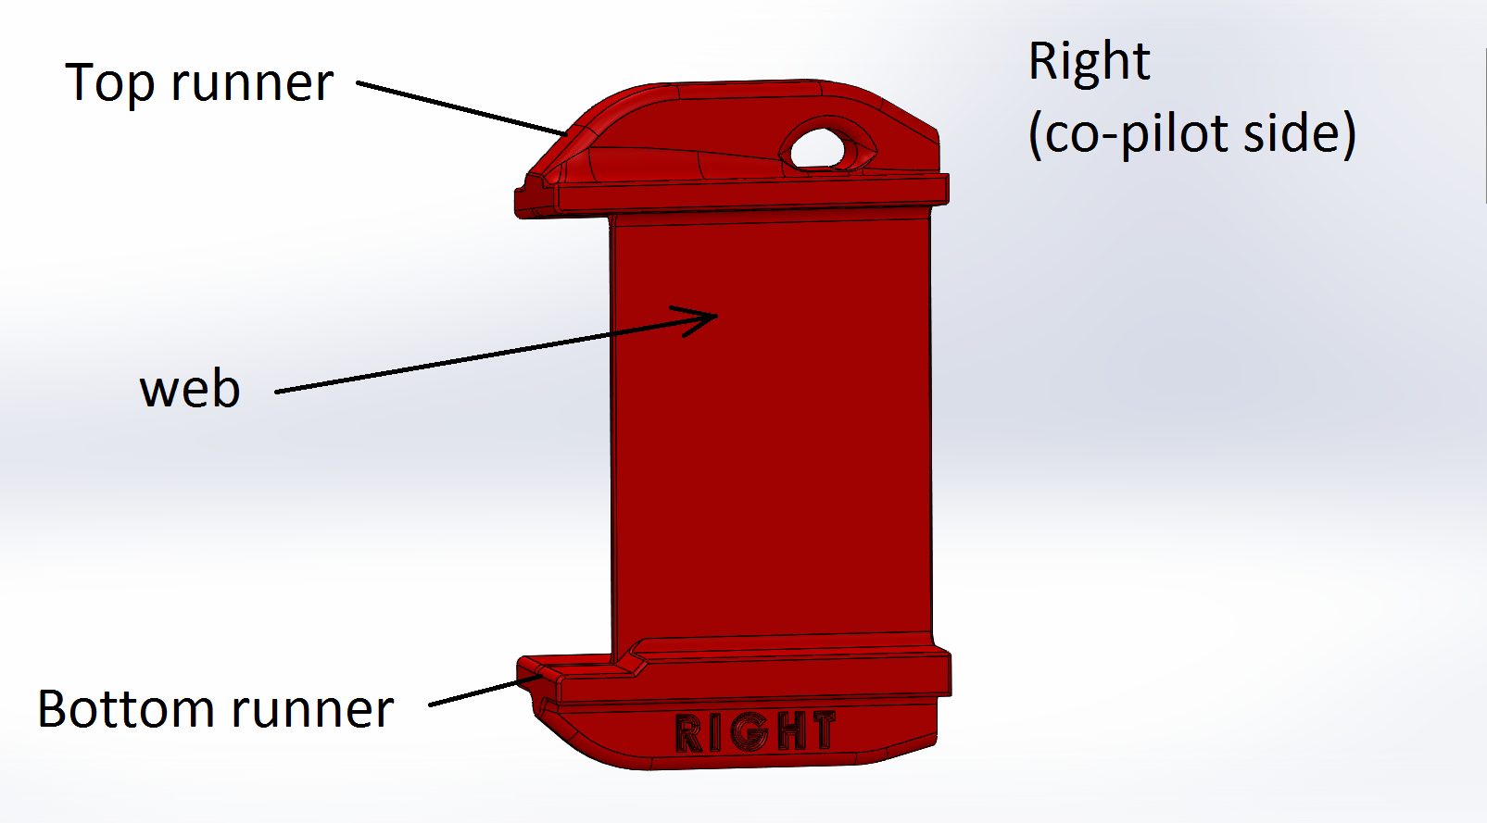
Step 1. Lay tape .250 inch from Elevator horn leading edge. This will be the reference measure line.
Step 2. Measure Elevator Horn Max Vertical Dimension across the Leading Edge. In this example the value = 3.300 inch. Round up to nearest .005, so in this case, the value would be 3.300 inch (no rounding needed). Select 3.300 from the product selection list.
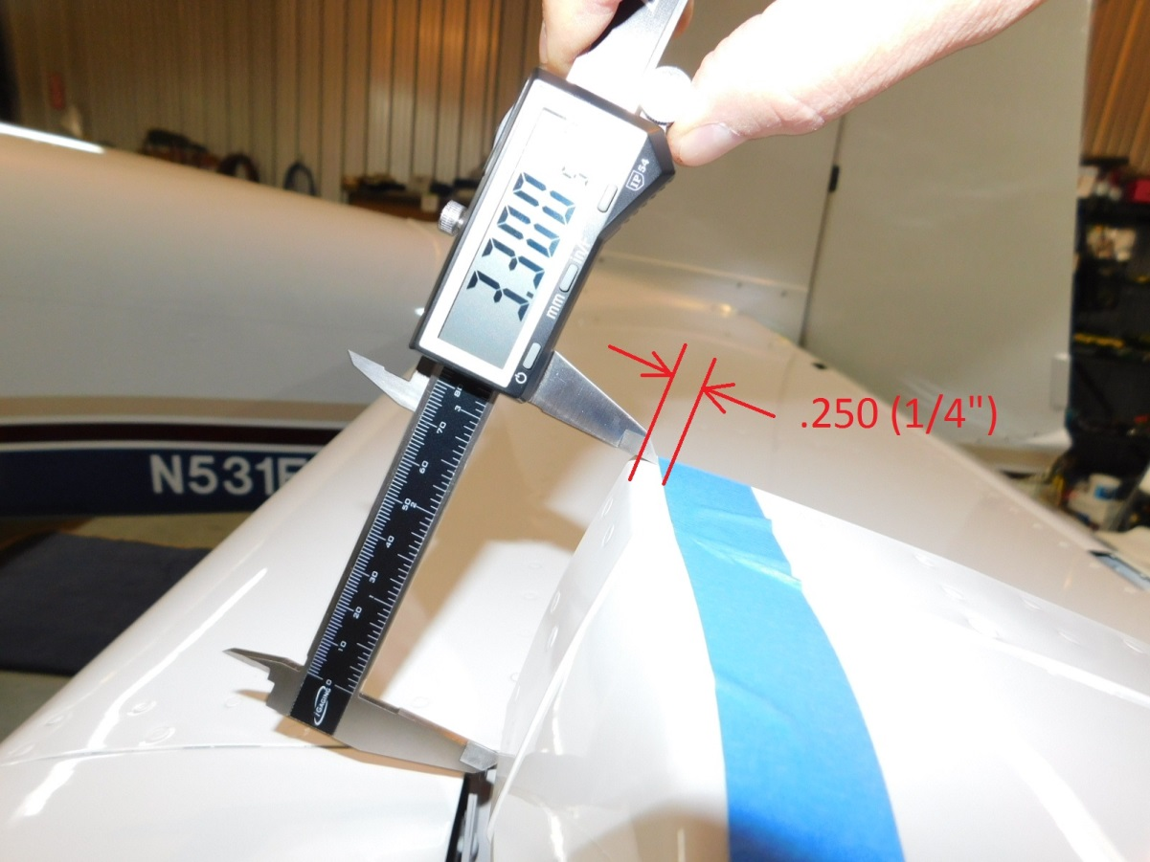

Step 3. Lay tape .250 inch from Fairing trailing edge. This will be the reference measure line.
Step 4. Measure Fairing Max Vertical Dimension across the fairing Trailing Edge. In this example the value = 3.308 inch. Round up to nearest hundredth, so in this case, the value would be rounded to 3.310 inch. Select 3.310 from the product selection list.
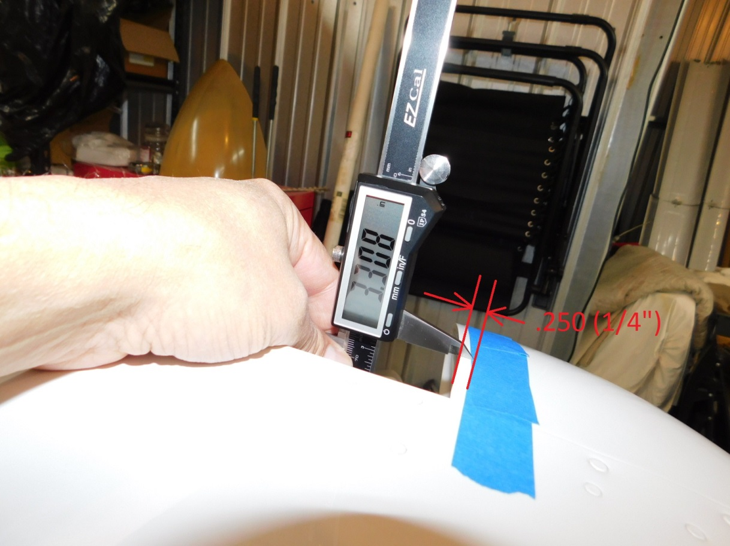

Step 5. Measure the minimum gap with the elevator in the horizontal position. This is the position of the elevator when the gust lock is installed. A feeler gauge or similar may be needed. Record minimum dimension and compare to web thickness selection list. .150 inch gap or greater choose thick web. Less than .150 inch gap, choose thin web. The typical RV-9 and RV-14 curvature of the fairing affects to ease of installation so that is why a .150 gap or less requires the thin web. If the fairing trailing edge straight then a thick web could be used for a gap .125 inches or greater.
Actual printed part web thicknesses:
Thin = .068 inch
Thick = .098 inch

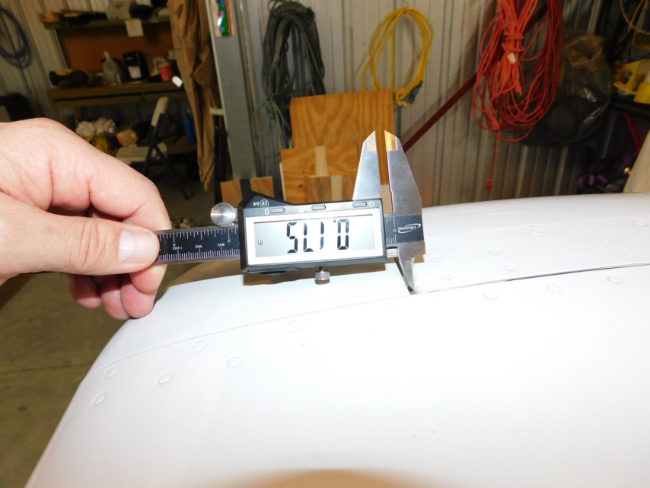
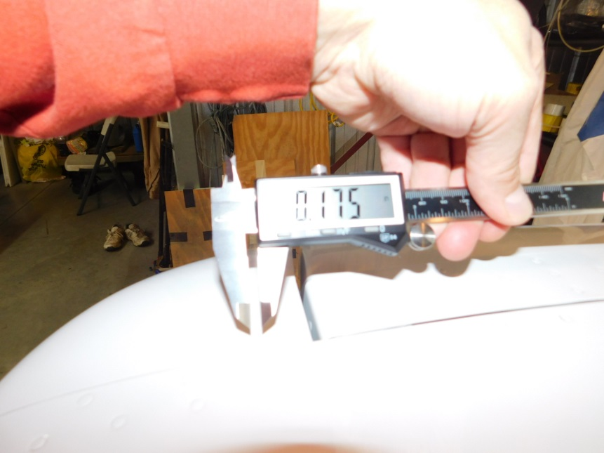

Step 6. Repeat measurements for opposite side. As you will need both left (pilot side) and right (co-pilot side).

Measurement table
Left Hand Side | Measurement (inches) | Round up to nearest .005
Fairing Max Vertical Dim
Elevator Horn Max Vertical Dim
Gap
Right Hand Side | Measurement (inches) | Round up to nearest .005
Fairing Max Vertical Dim
Elevator Horn Max Vertical Dim
Gap

