RV-9 Flap Bracket Fairing
rvplasticparts.com

Orientation: Left to Right
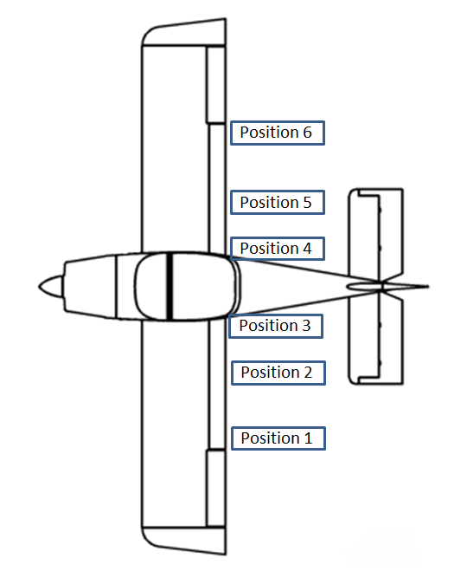
Forward fairing: Unique for each position. The bolt head faces outwards.
Position 1 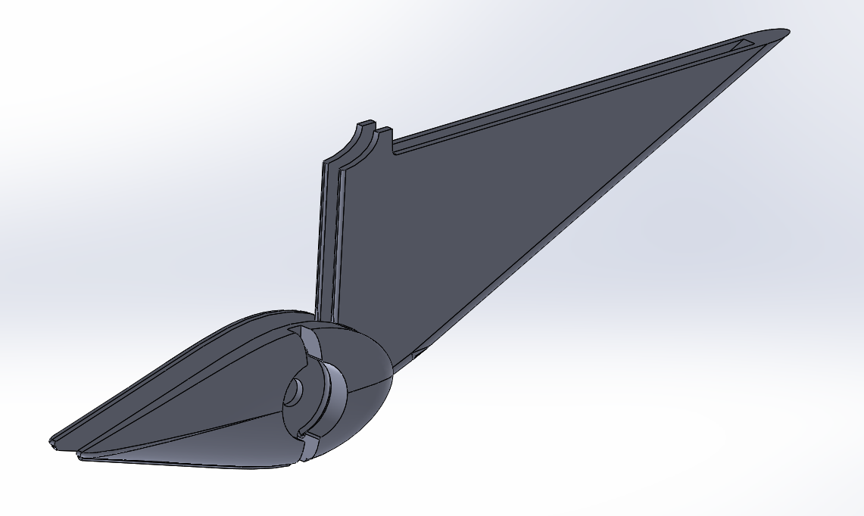
Position 2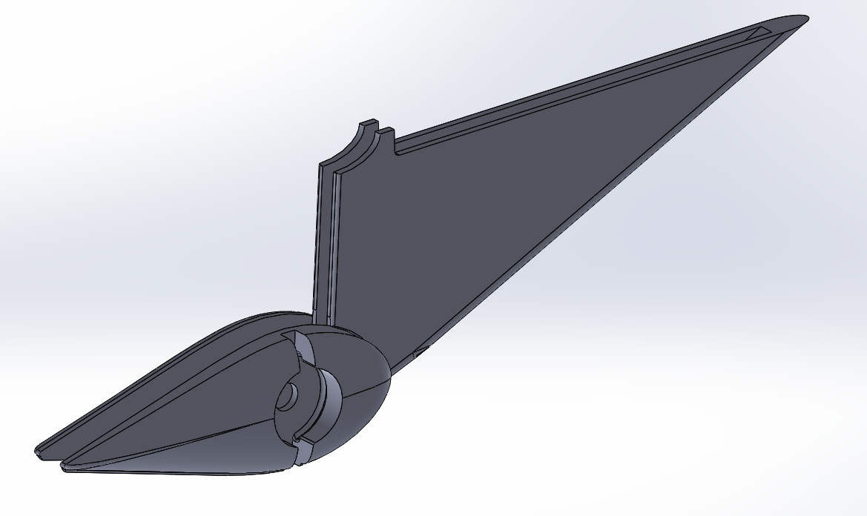
Position 3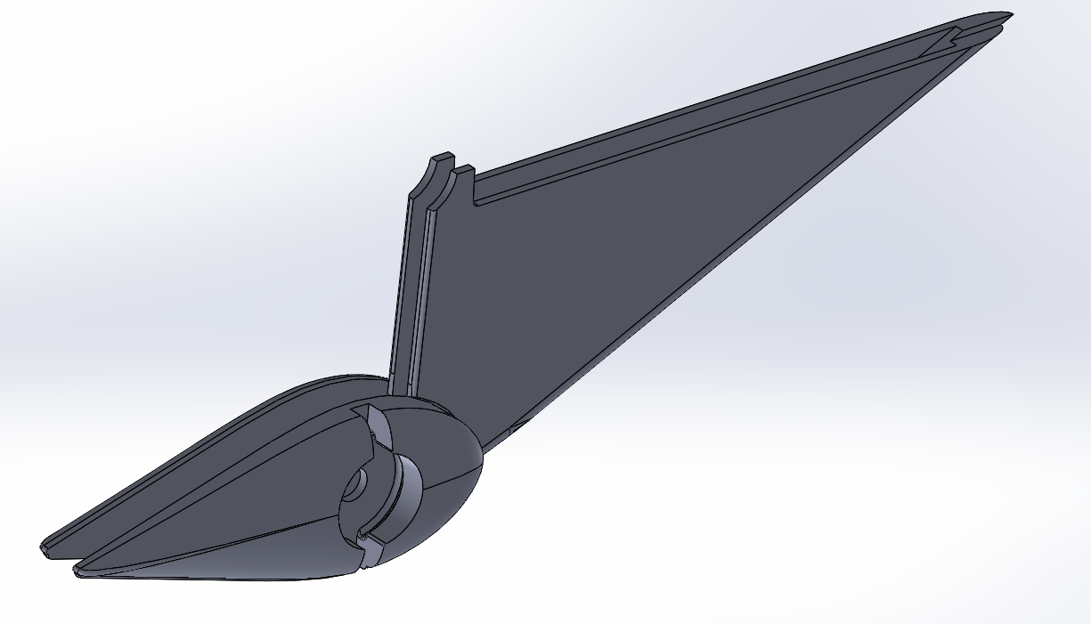
Position 4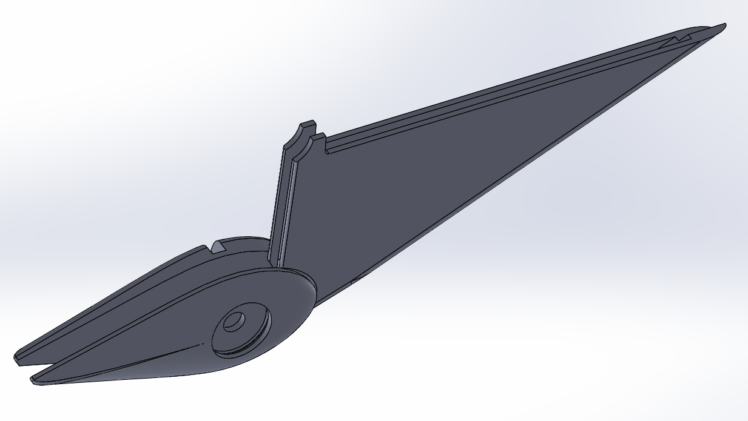
Position 5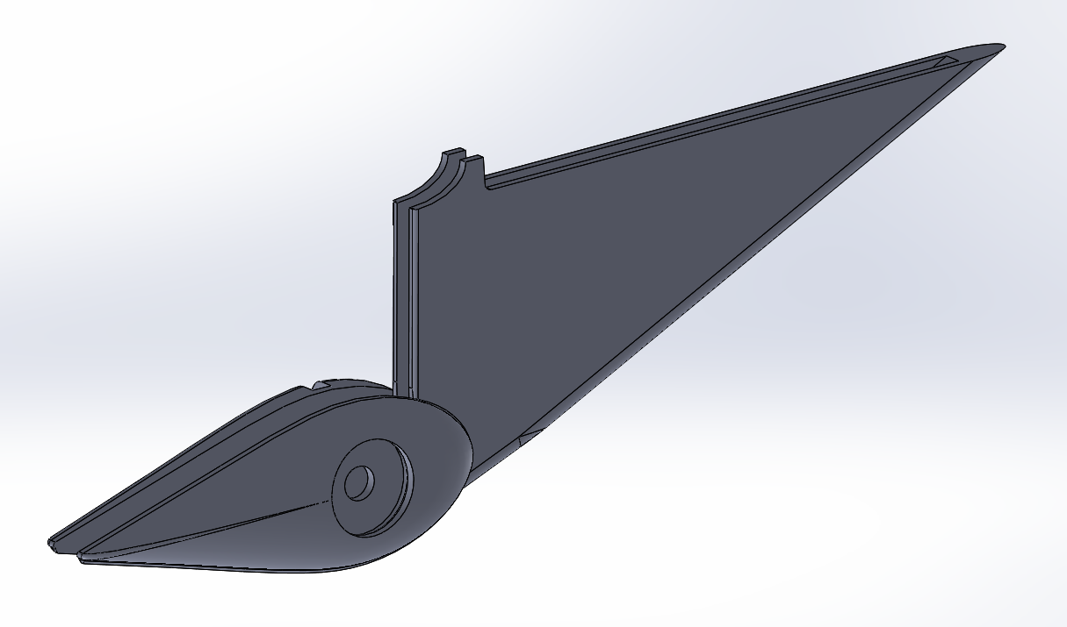

Position 6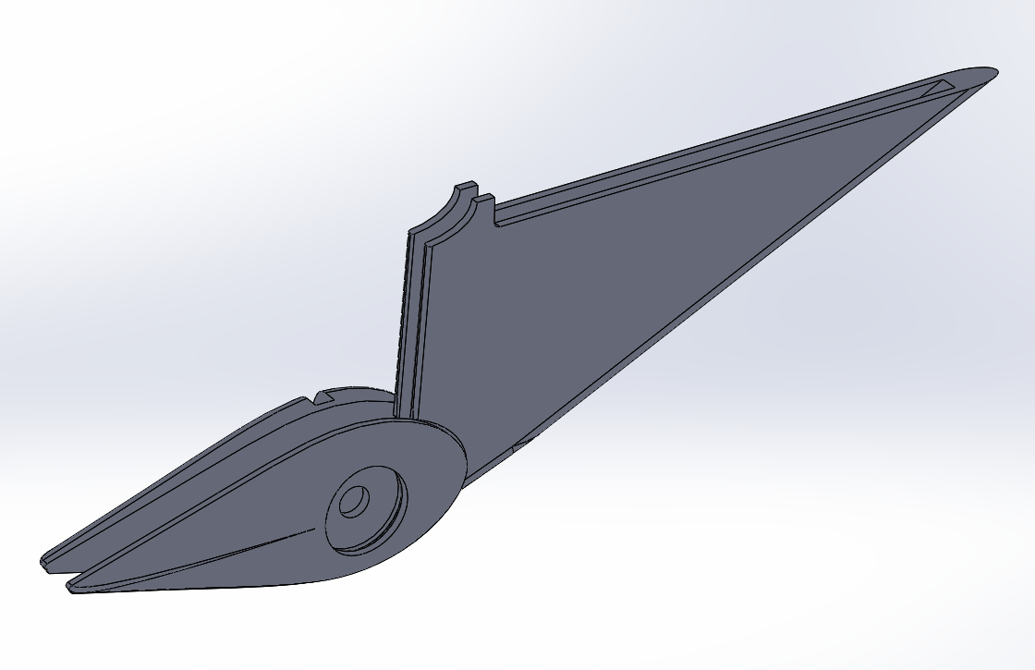
Aft fairing
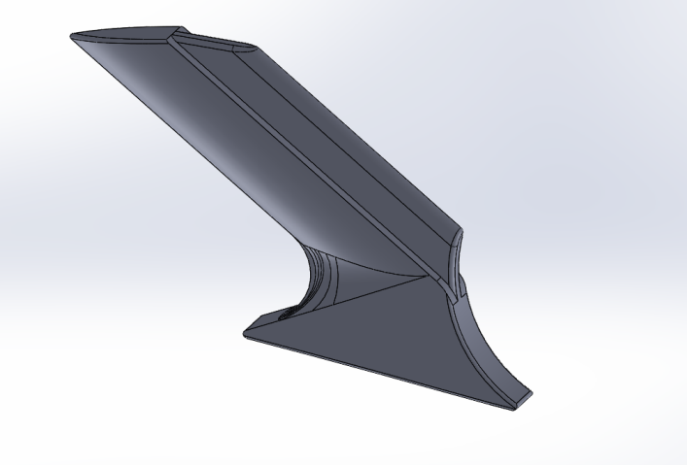

Nut button
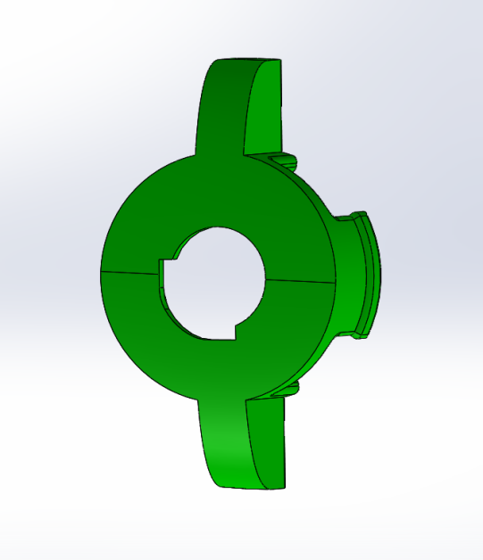 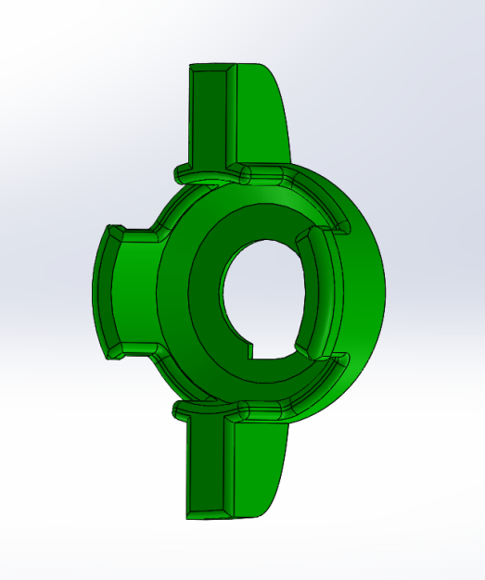
Right Hand Face Right Hand Back
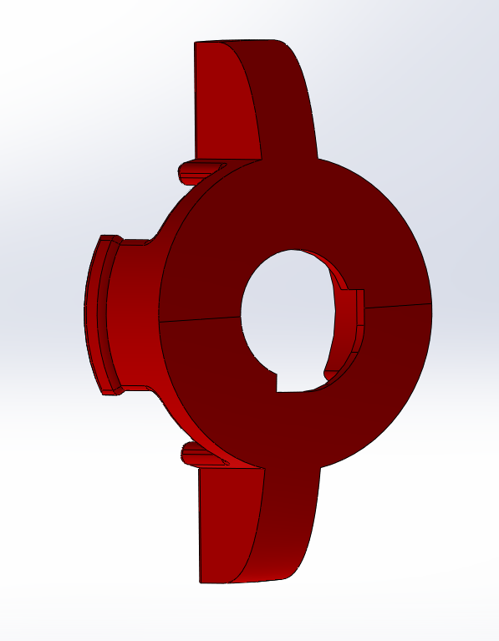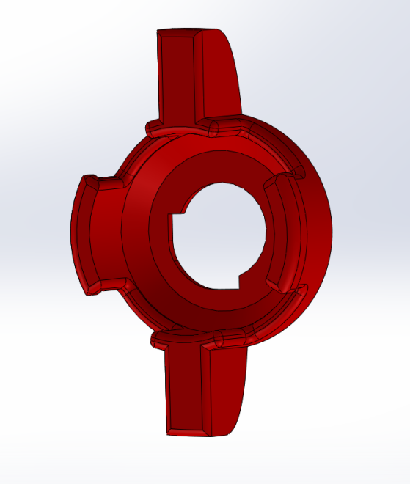
Left Hand Face Left Hand Back

Head button
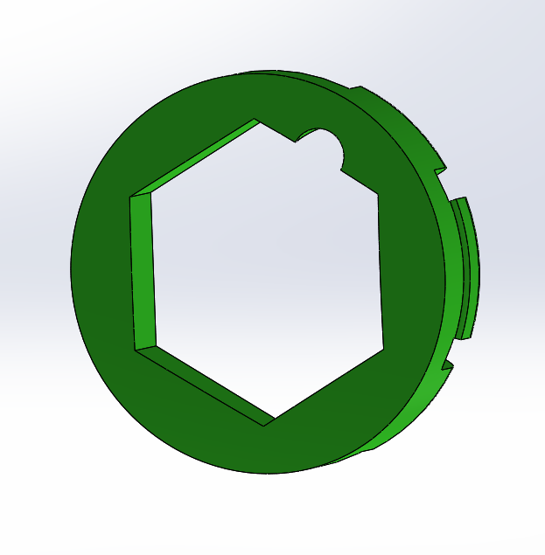 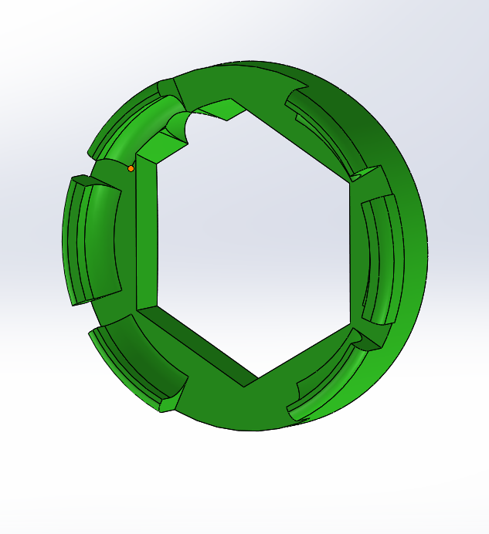
Right Hand Face Right Hand Back

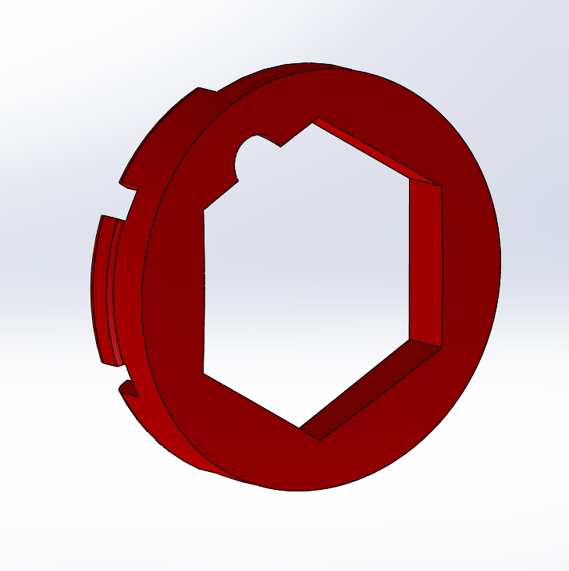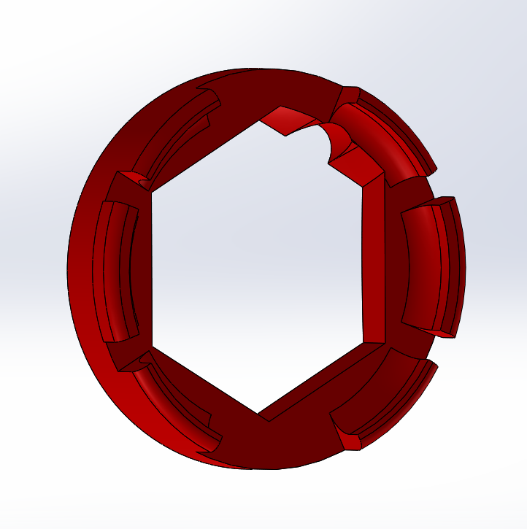
Left Hand Face Left Hand Back

Bolt: AN4-6
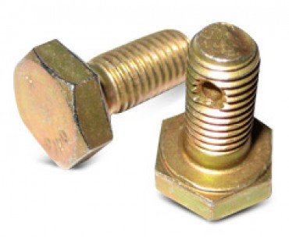

Castle Nut: AN310-4
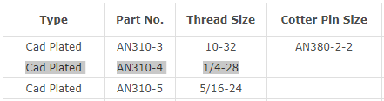
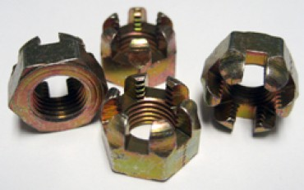

Cotter Pin: 380-2-2, MS24665-132 COTTER PIN - CADMIUM PLATED
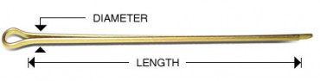
Identification dimensions
Positions 1 and 6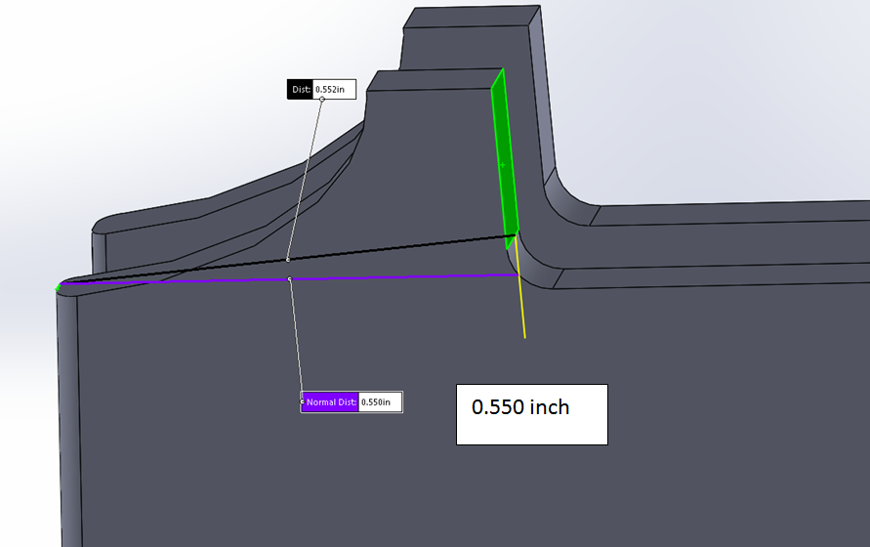
Caution: do not file or sand this face since it will affect fit up.
Positions 2 and 5
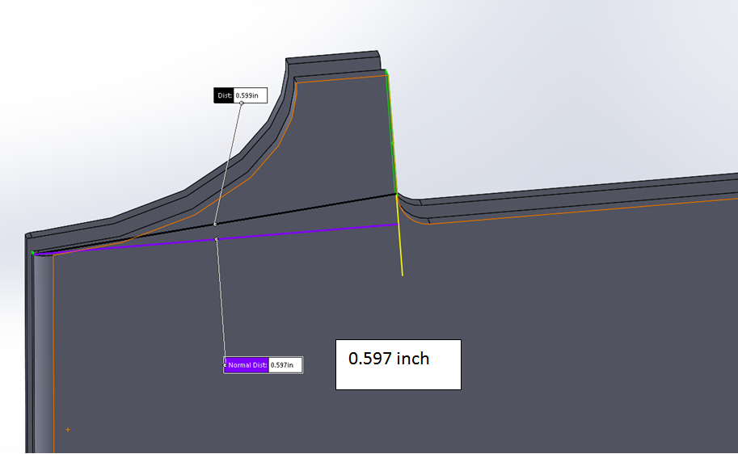

Positions 3 and 4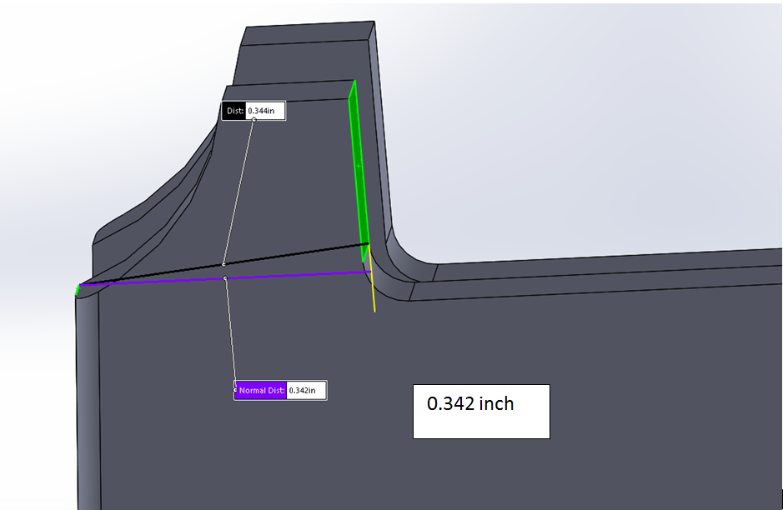

Caution: do not file or sand this face since it will affect fit up.
Step 1: Remove the plastic support material from the plastic pieces and sand or file away plastic nibs.
Forward fairing: pull, pinch with needle nose pliers, twist
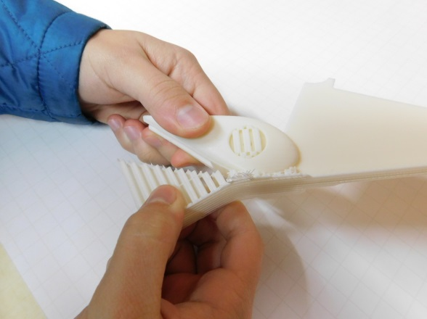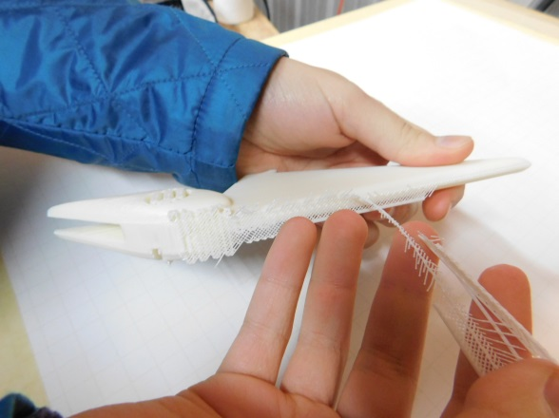
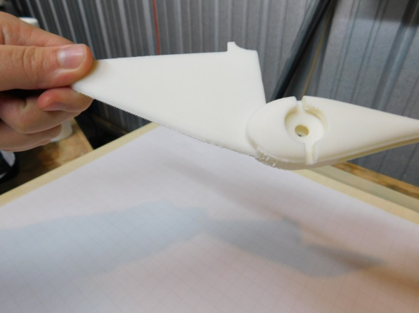

Aft fairing: pinch with needle nose pliers, pull
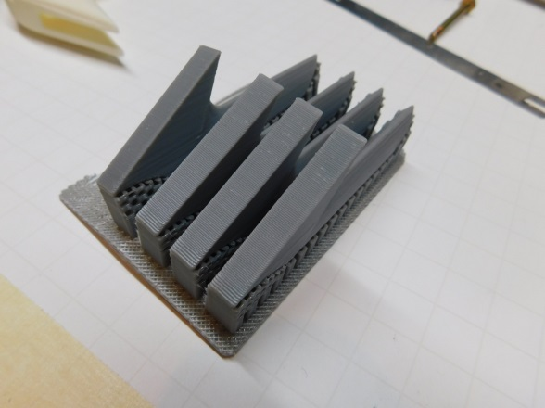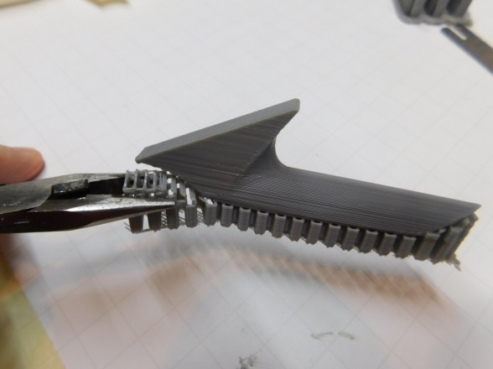
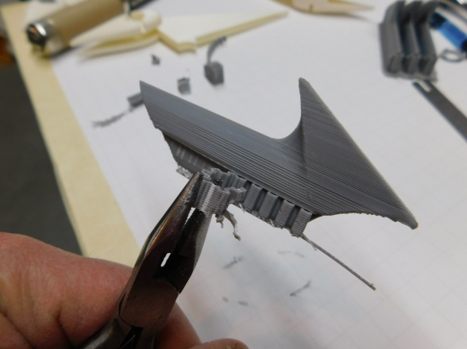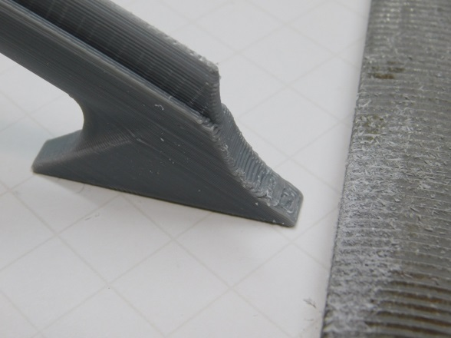

Nut button: pinch with needle nose pliers, twist
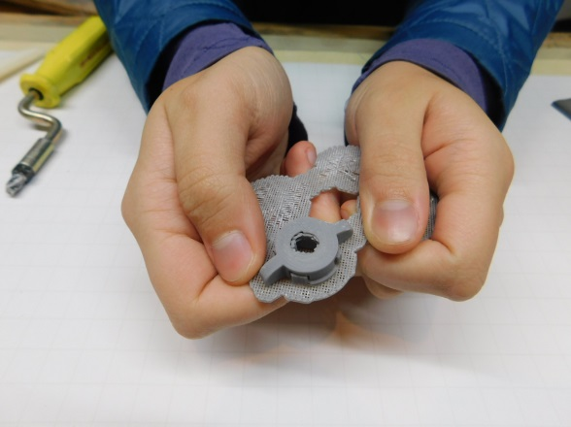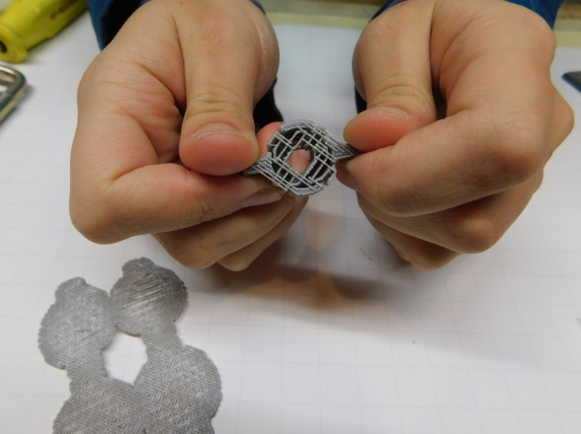
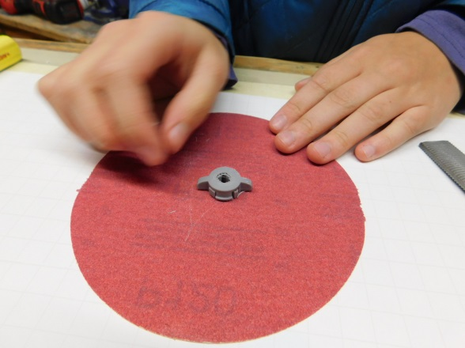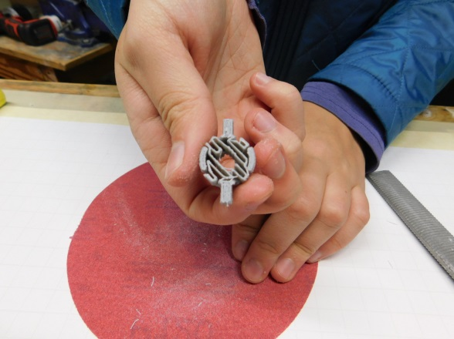

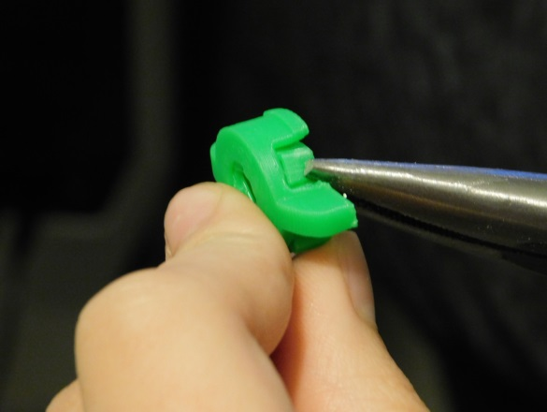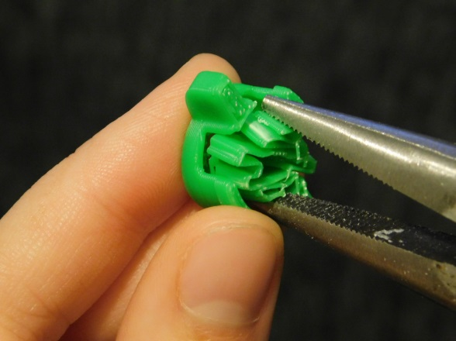
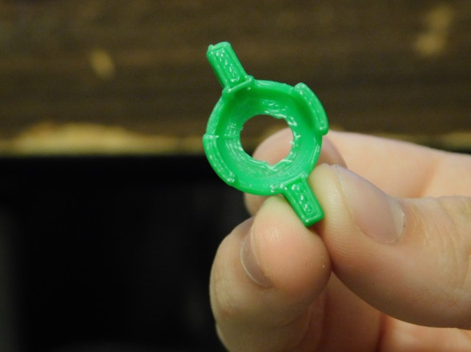

Head button: pinch with needle nose pliers, twist
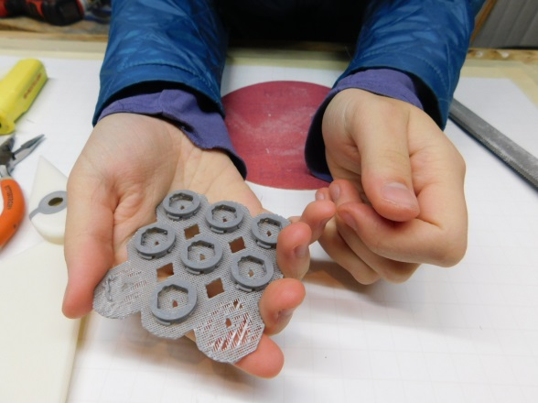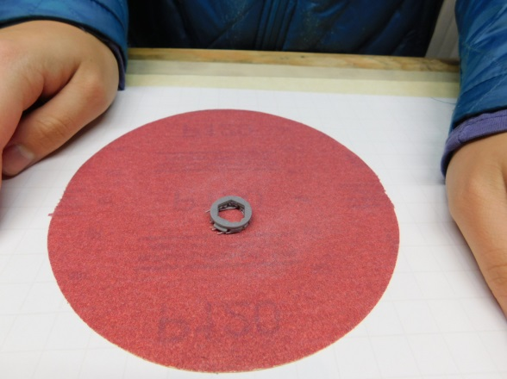
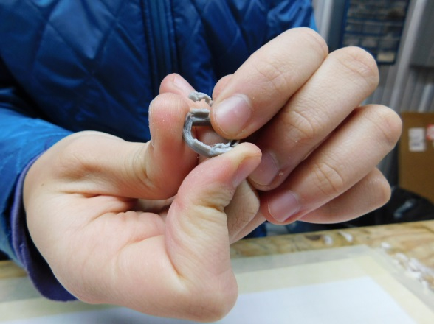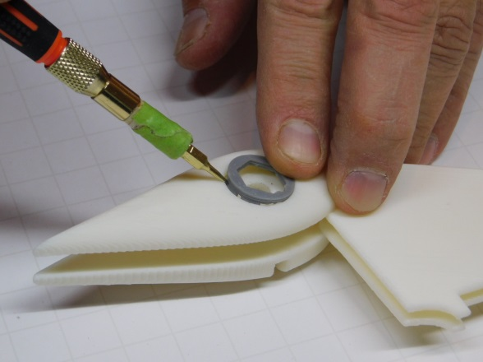
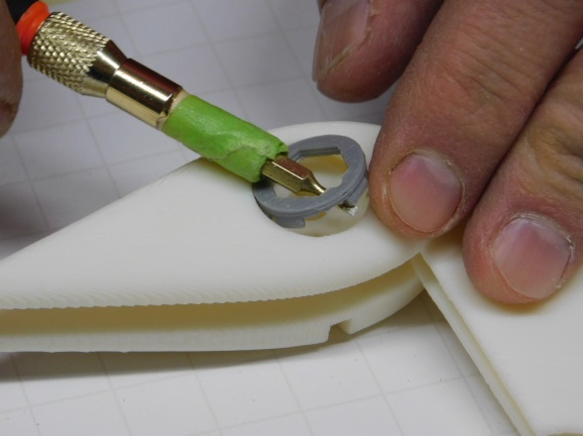

Step 2: Use a belt sander and a file to remove build-up material from the Forward fairing underside. 0.035 build-up was added for printing is to be removed. CAUTION: the underside of the fairing is thin to achieve a low profile. Remove material slowly.
Forward fairing
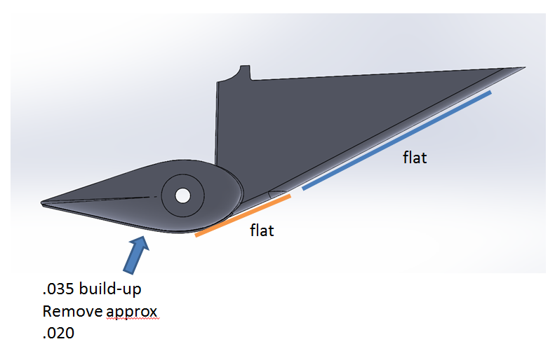

CAUTION: Thin area to achieve compact profile.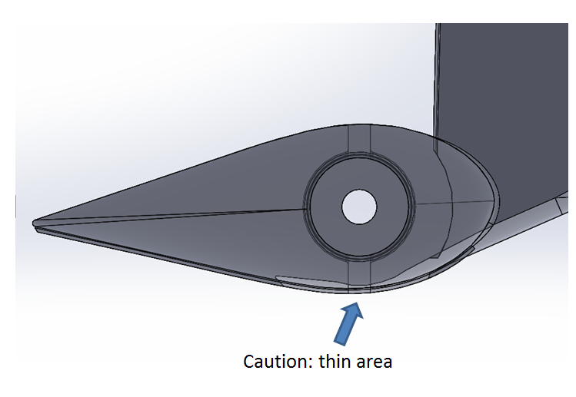
Caution: do not file or sand this face since it will affect fit up.

Aft fairing:
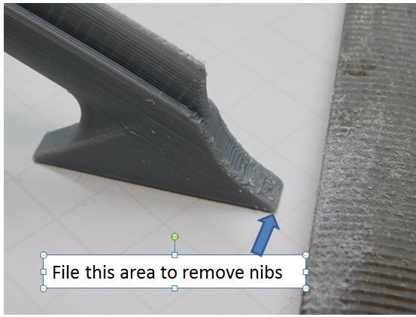
Step 3: Using a drill bit, open the hole in the Forward fairing to be 0.250 inch diameter. Be sure to use the proper size drill bit as this will affect fit up.
Forward fairing
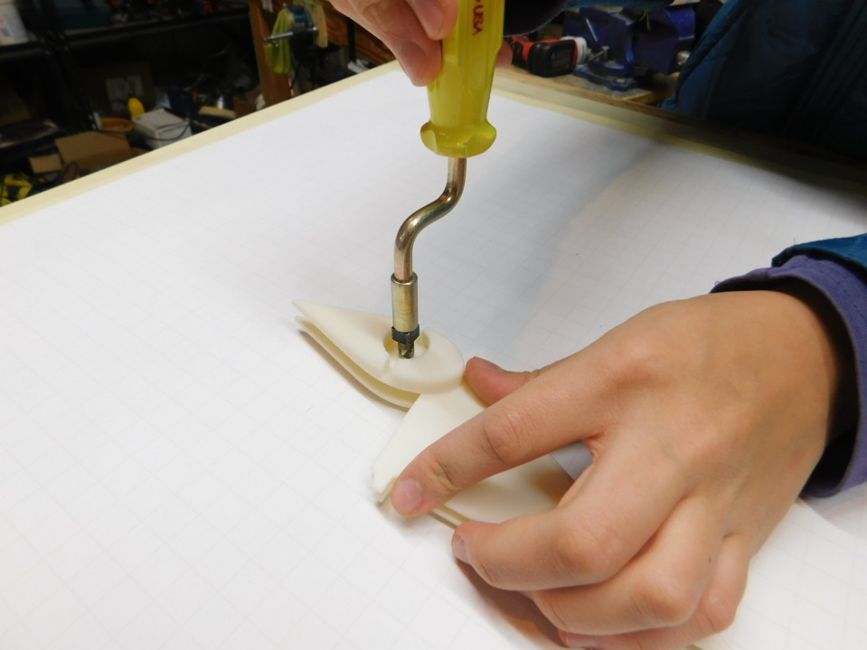

Step 4: Position the flaps to approximately downwards from full up position to relieve pressure from top wing skin and ease installation.

Step 5: Trim the cotter pin long side by 0.250 inch using snips.
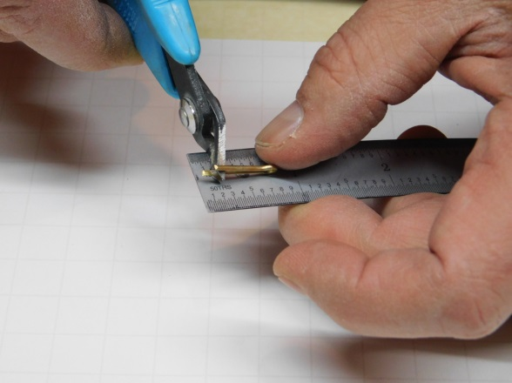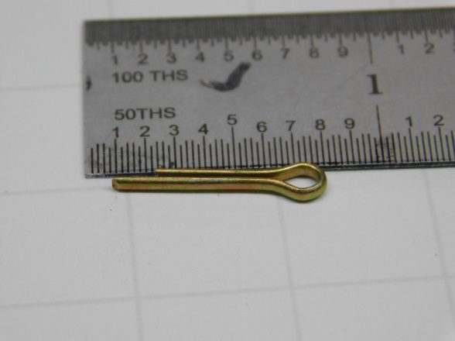

Step 5A: Chase bolt thread with castle nut. It was found beneficial to apply light oil and chase the bolt threads with the castle nut to ease installation alignment in a later step.
Step 6: Install the Forward flap fairing using an AN4-6 bolt. A long undersized bolt was found be beneficial to align flap and flap bracket holes prior to installing the bolt. No metal washers are used for the installation
Forward fairing: Place open end first and slide into position
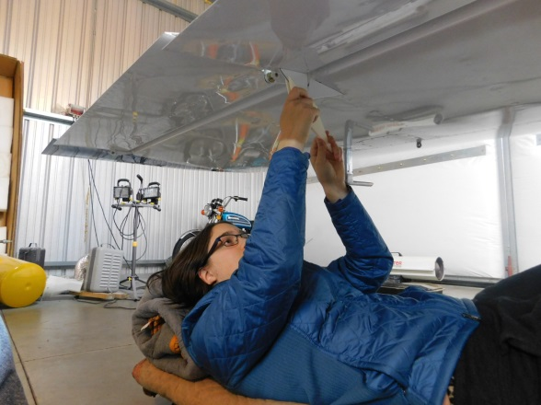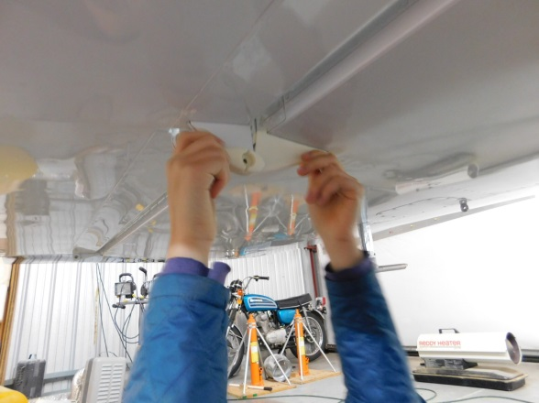

Step 7: Install nut and tighten to seat, then loosen nut approximately ¼ turn and align to cotter pin hole.
Step 8: Install cotter pin and nut button
Cotter pin and nut button: with the longest side forward, insert cotter pin (380-2-2) and pull to seat completely because it is a tight clearance when rotated into final position. Bend cotter pin into position with forward side up and aft side back. Install nut button by engaging upper side and then lower side. Rotate bolt 90 degrees to final positon with cotter pin bent side forward.
CAUTION: The nut button can only be installed or removed when the cotter pin is oriented vertically.

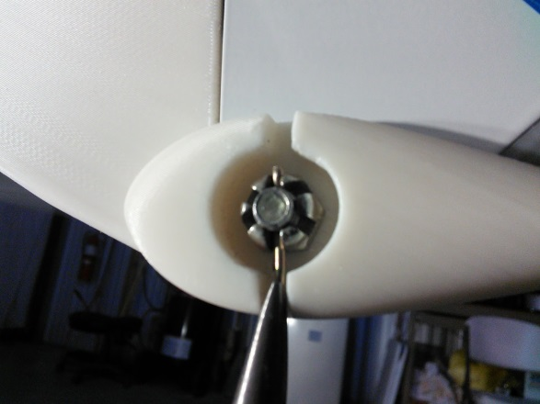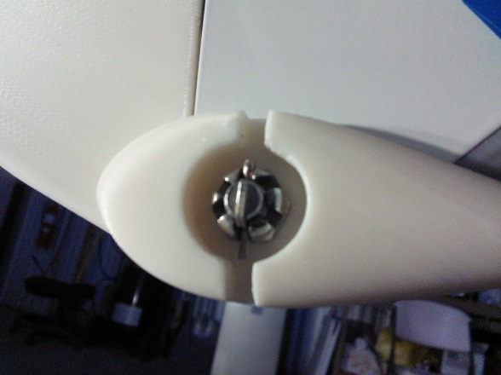
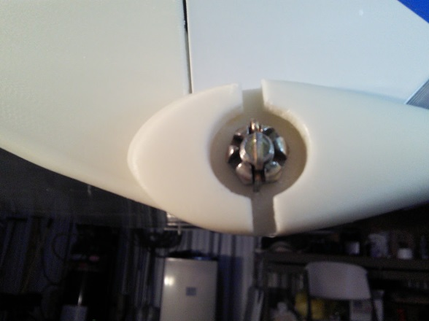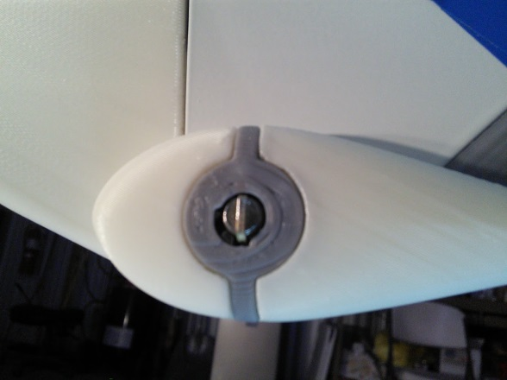
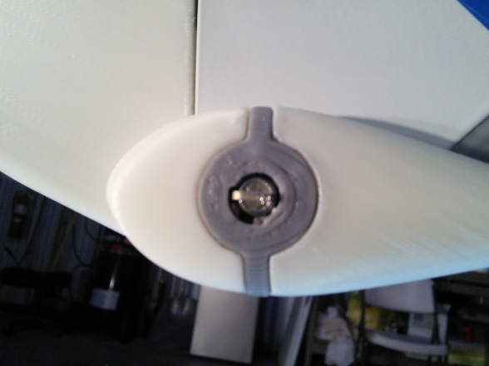

CAUTION: The nut button can only be installed or removed when the cotter pin is oriented vertically.

Step 9: Install head button
Note the orientation of the small hole in the side of the head button. Insert forward side of the head button into the groove and against the flat of the bolt head. Use a small flat screw driver to push the aft tang into the final position. To remove the head button, use a small screw driver and pry out.
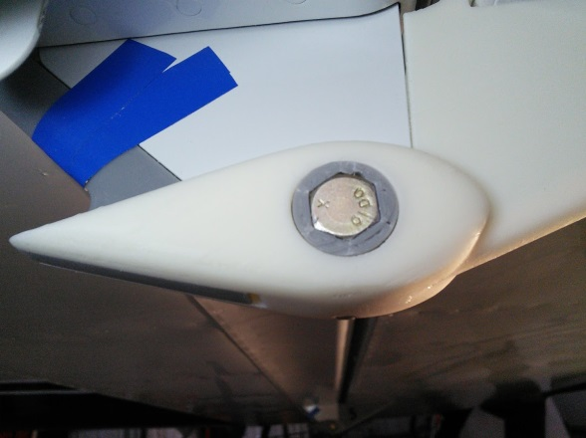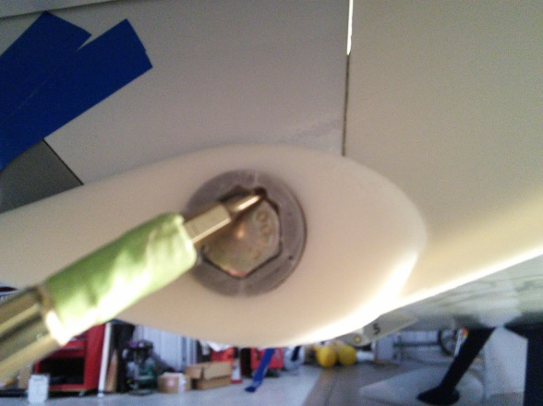

Step 10: Install Aft fairing. Align top aft trailing edge as shown.
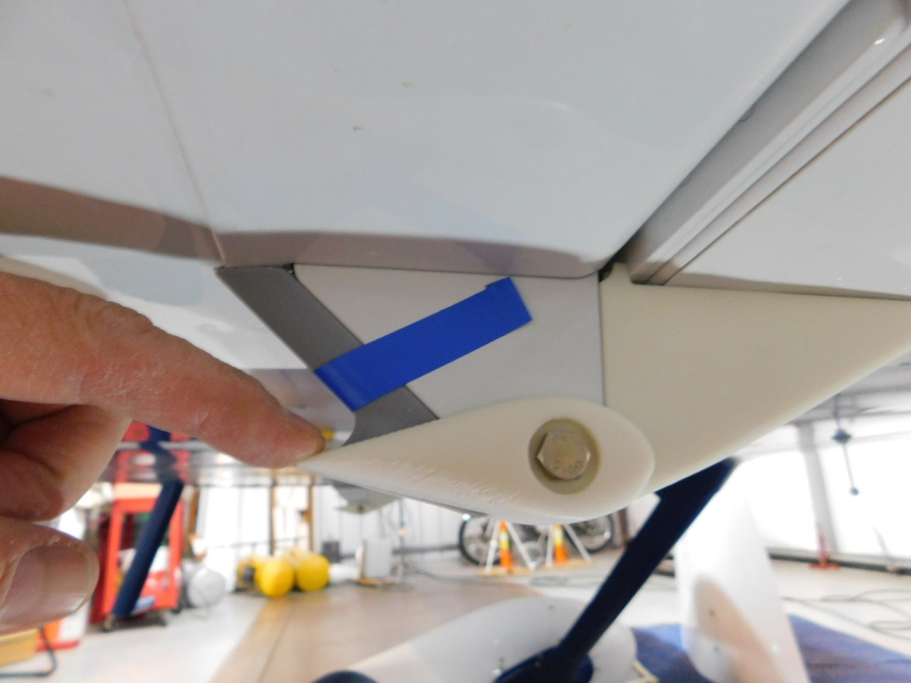

Trim upper aft fairing as required to achieve fit.
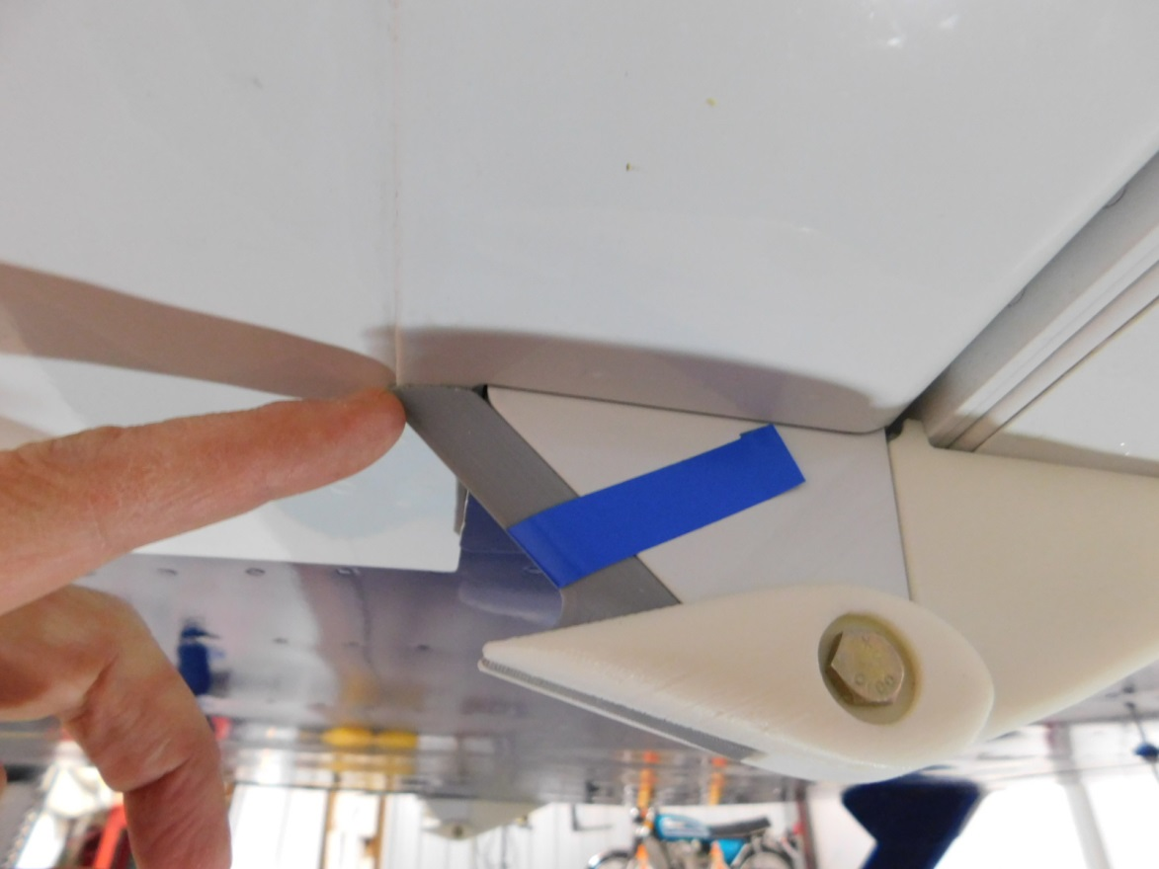

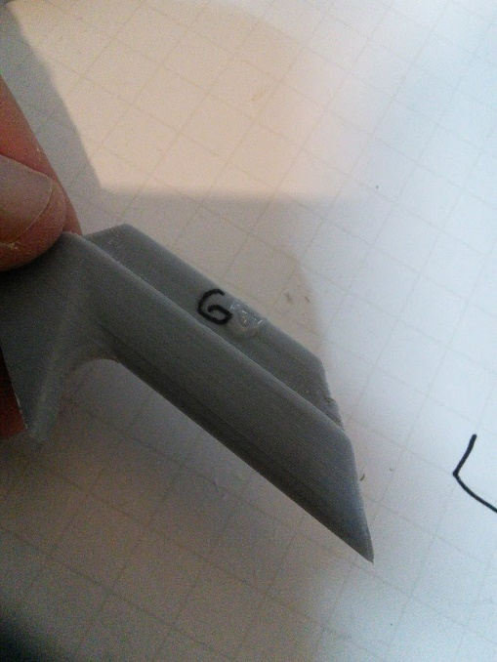
Place tape on Aft fairing to secure position and file underside of fairing to achieve a smooth contour. 0.010 inch has been added at printing to the lower side of the aft fairing to allow for removal to achieve a smooth contour. Once you get the aft fairing where you want it you will need to glue it in place. The G is where you place the glue.
Contour lower side by filing or sanding.
