RVPlasticParts.com
Elevator Gust Lock Measurements
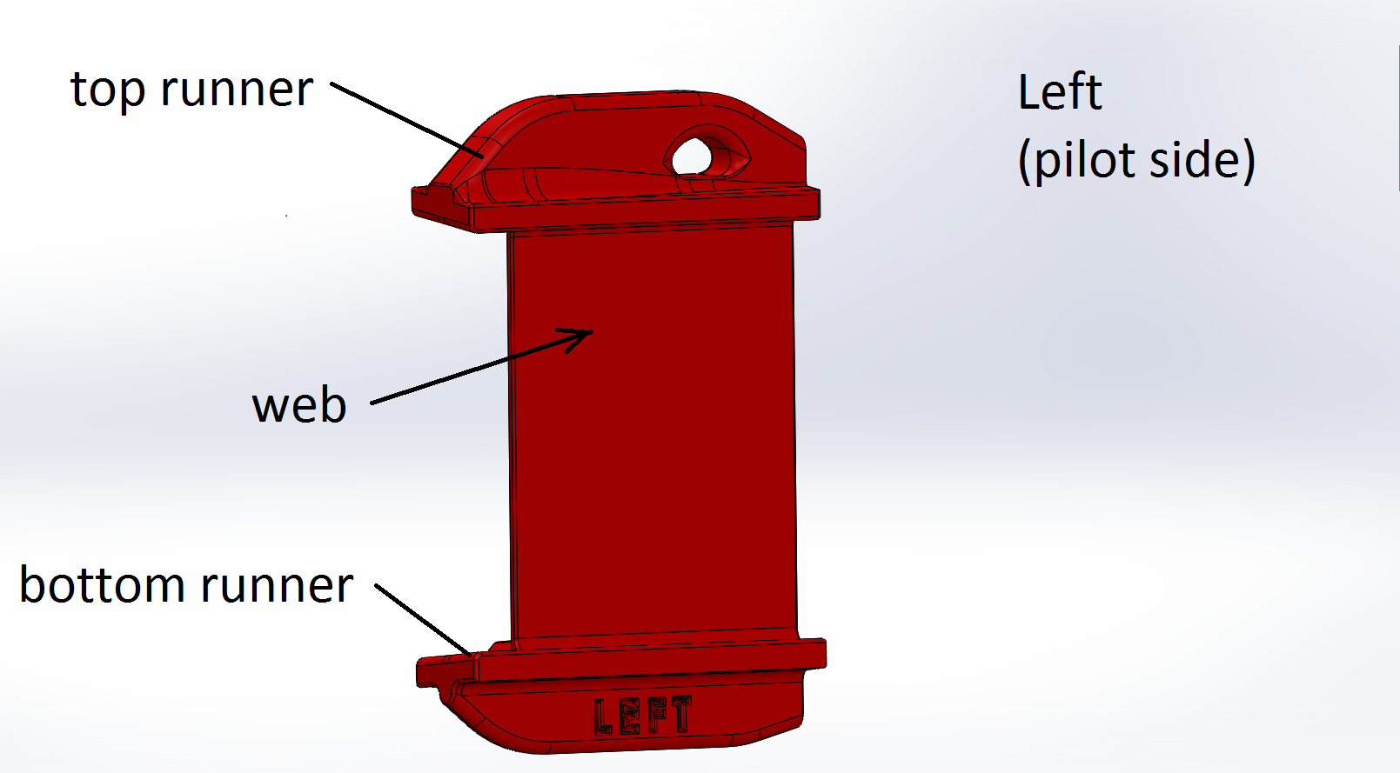

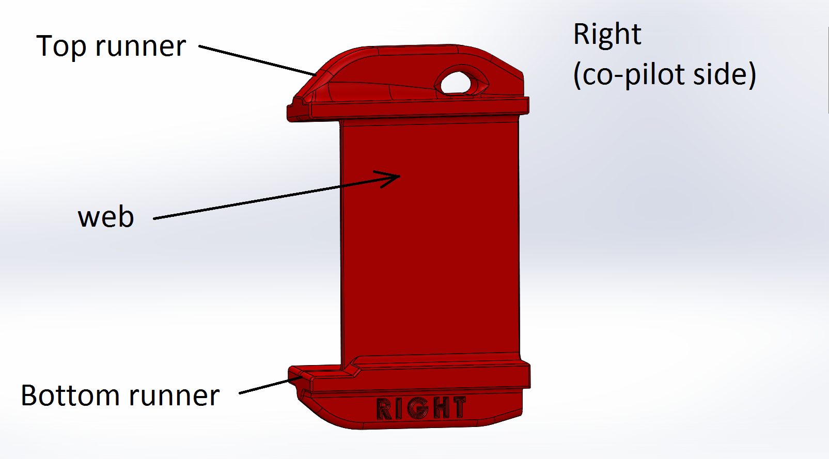
Step 1. Lay tape .250 inch from Elevator horn leading edge. This will be the reference measure line.
Step 2. Measure Elevator Horn Max Vertical Dimension across the Leading Edge. Note: The Elevator Horn is the moving part. In this example the value = 3.300 inch. Round up to nearest .005, so in this case, the value would be 3.300 inch (no rounding needed). Select 3.300 from the product selection list.
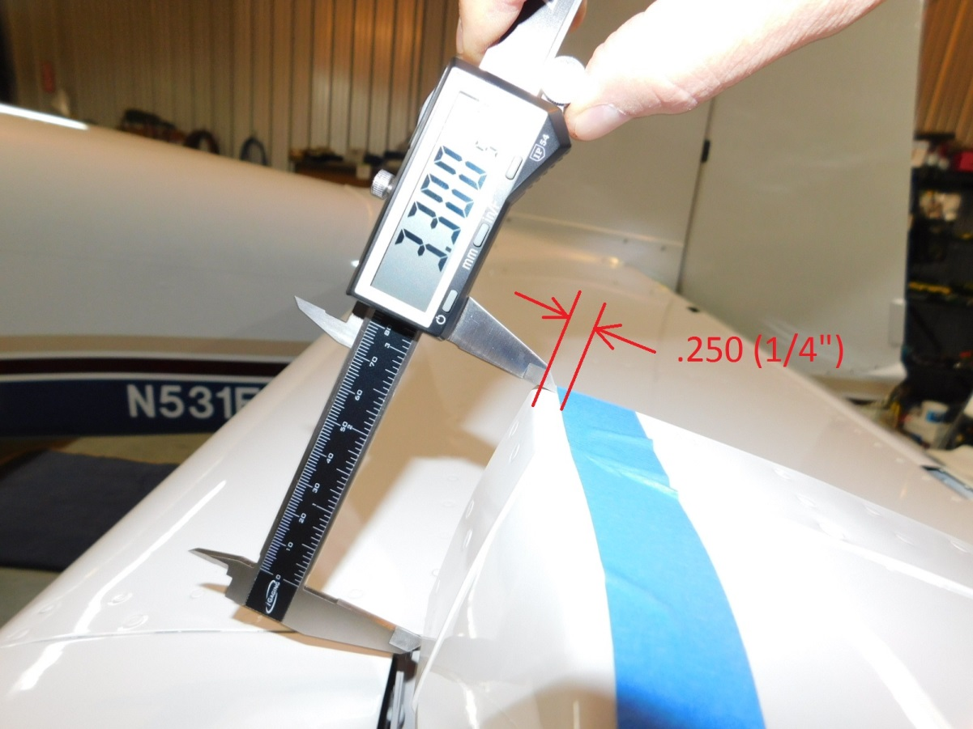
This is the Left Hand Side Elevator Horn, the moving part.

Step 3. Lay tape .250 inch from Fairing trailing edge. This will be the reference measure line.
Step 4. Measure Fairing Max Vertical Dimension across the fairing Trailing Edge. Note: The fairing is the fixed part. In this example the value = 3.308 inch. Round up to nearest hundredth, so in this case, the value would be rounded to 3.310 inch. Select 3.310 from the product selection list.
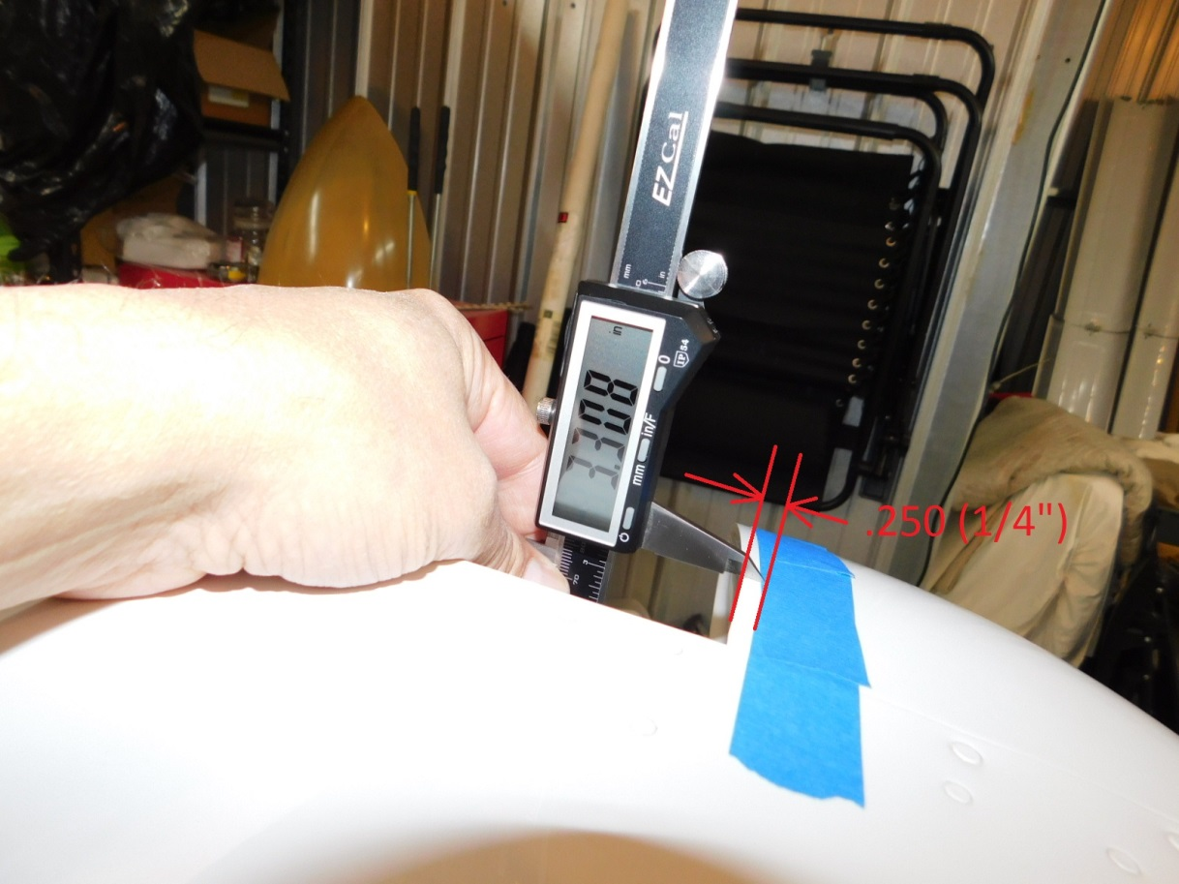
This is the Left Hand Side Fairing, the fixed part.

Step 5. Measure the minimum gap with the elevator in the horizontal position. This is the position of the elevator when the gust lock is installed. A feeler gauge or similar may be needed. Record minimum dimension and compare to web thickness selection list. .150 inch gap or greater choose thick web. Less than .150 inch gap, choose thin web. The typical RV-9 and RV-14 curvature of the fairing affects to ease of installation so that is why a .150 gap or less requires the thin web. If the fairing trailing edge straight then a thick web could be used for a gap .125 inches or greater.
Actual printed part web thicknesses:
Thin = .068 inch
Thick = .098 inch

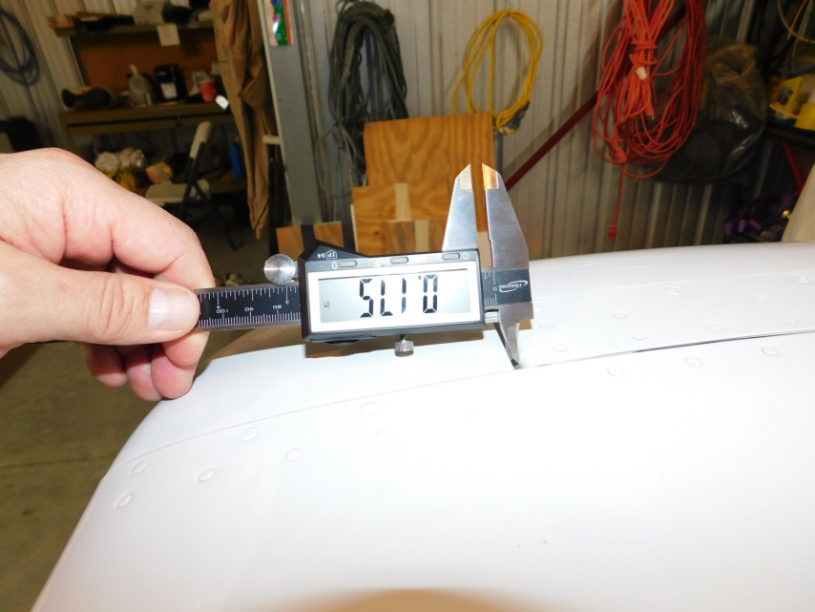
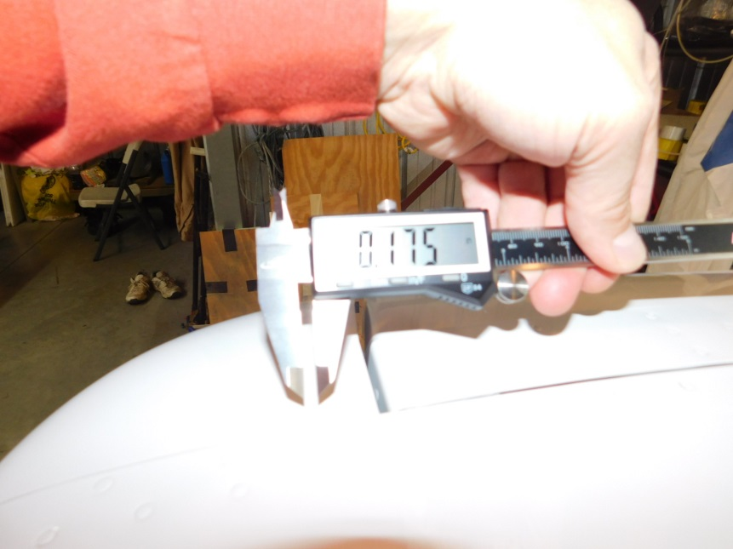

Step 6. Repeat measurements for opposite side. As you will need both left (pilot side) and right (co-pilot side).

Measurement table
Left Hand Side | Measurement (inches) | Round up to nearest .005
Fairing Max Vertical Dim (fixed part)
Elevator Horn Max Vertical Dim (moving part)
Gap
Right Hand Side | Measurement (inches) | Round up to nearest .005
Fairing Max Vertical Dim (fixed part)
Elevator Horn Max Vertical Dim (moving part)
Gap

Rope
Size: ¼ inch diameter
Type: Use a stiff rope such as Dyneema with braided polyester cover or similar. This is the type of rope used on sailboats and is weather resistant and stiff.
***********
Installation
When the rope setup is completed you will only need to make one knot to install the gust locks.
Step 1. Install Right Hand Side Elevator Gust Lock
Step 2. Swing Rudder to the Right and Install the Rudder Gust Lock
Step 3. Install Left Hand Side Elevator Gust Lock
Step 4. Tighten and Tie knot
Note: You will not damage the rudder by tightening because the rudder is free to move. The tension will be taken by the rope on the opposite side. When the gust locks are installed, the rudder will self-center with the rope and remain secure in both directions.
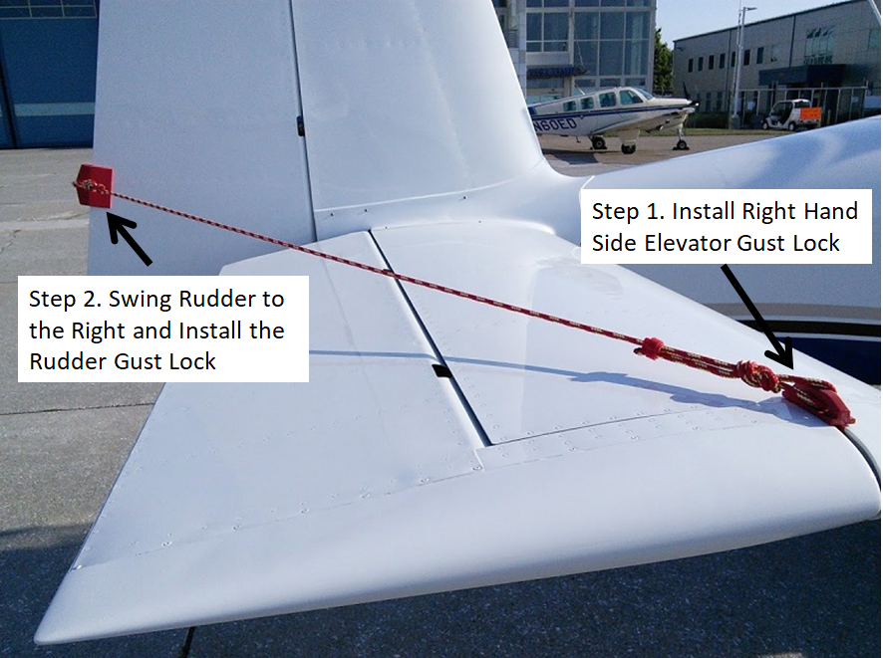
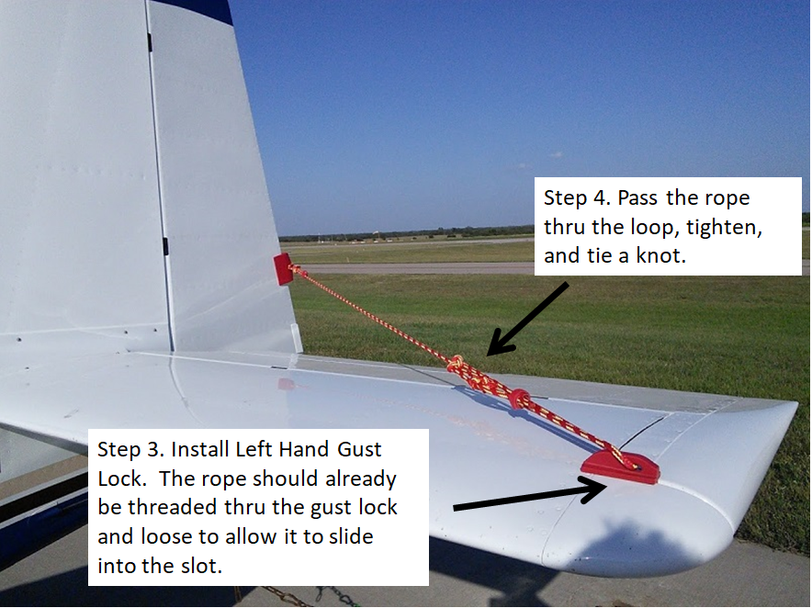

Knots

We use three basic knots. (You may prefer different knots)
- A Figure 8 knot to tie the Right side elevator gust lock and both the left and right side connections at the rudder gust lock.
- A Farmers loop to provide the loop in the line for tightening.
- A halter-hitch to secure the loop tie.
A Figure 8 knot looks like this. This is a good instructional video YouTube link for this knot. https://youtu.be/GFlwrvggas0

Rudder Figure 8 knot
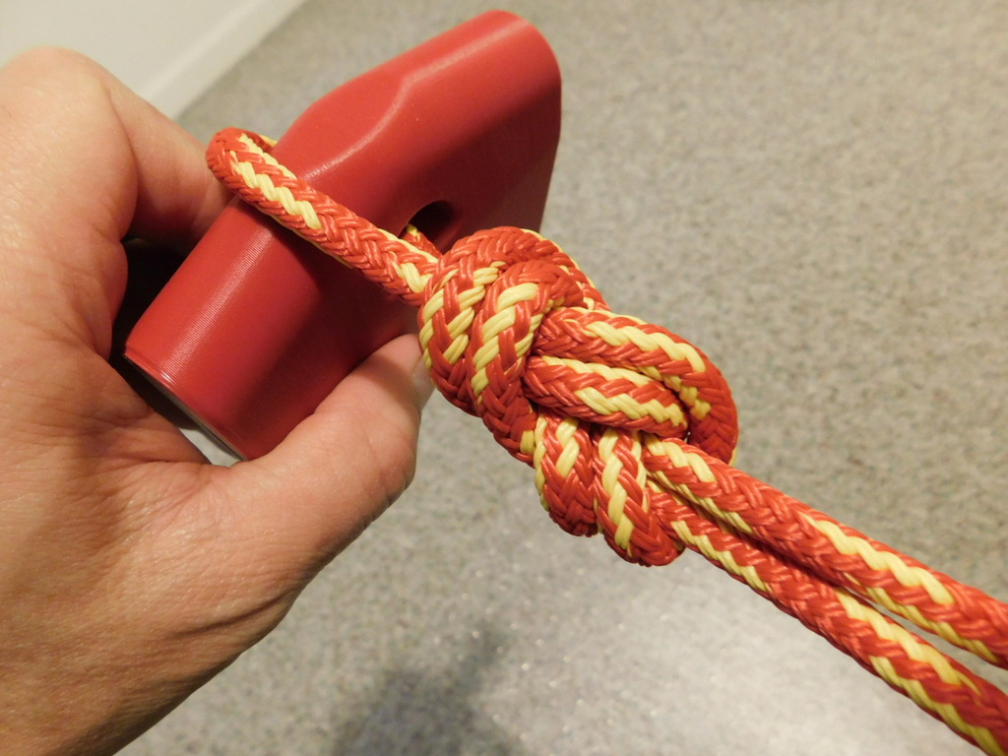

Rudder Figure 8 knot. Both sides tied independently. A zip tie keeps it neat.

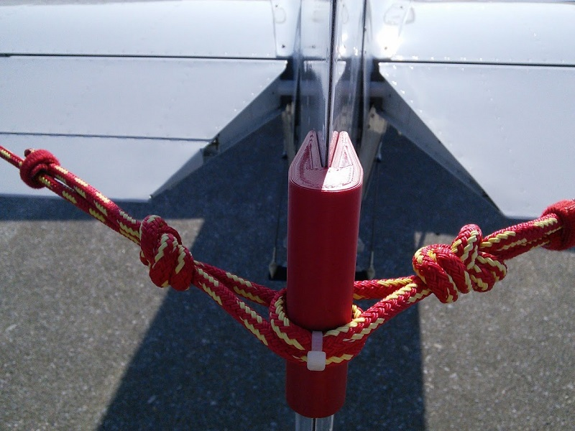

Right Hand Side Elevator Figure 8 knot
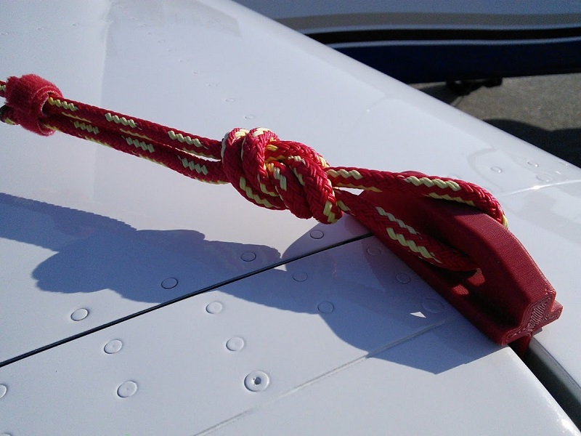

Farmers Loop and Halter-Hitch Knots

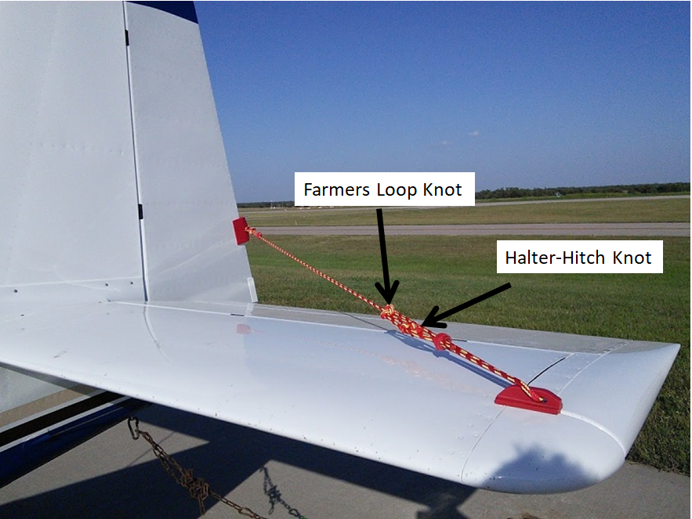

Farmers Loop
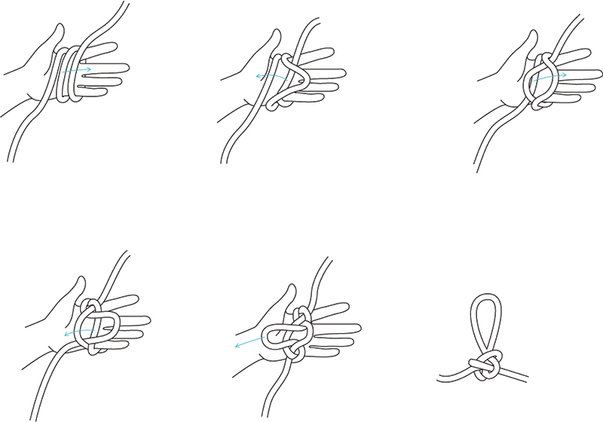

Halter-Hitch

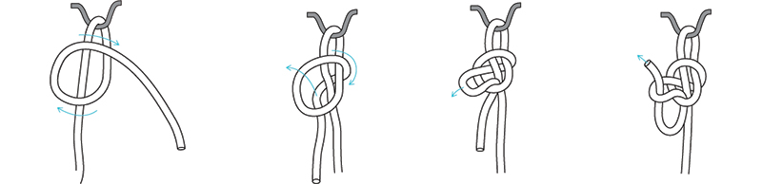

Velcro Cable tie rope loose ends if desired

